Guide Details and Assignment

Assumptions:

1.) Booking details table is already created which stores the data of booked tour packages.

2.) Records are present in the booking table.

Functionalities:

1.) Creation of a guide table which stores personal and contact details of guides employed.

2.) Displaying entire guide details using OOALV and adobe form.

3.) Assigning guides to the booked tour packages.

4.) Maintaining guide details through DML operations.

Navigation:

Server:

Package

Project: Tourism Management System

Sub-Project: Guides Details and Assignment

Guide Table:

Programs:

Adobe Form:

1.) The initial screen contains the guide details button.

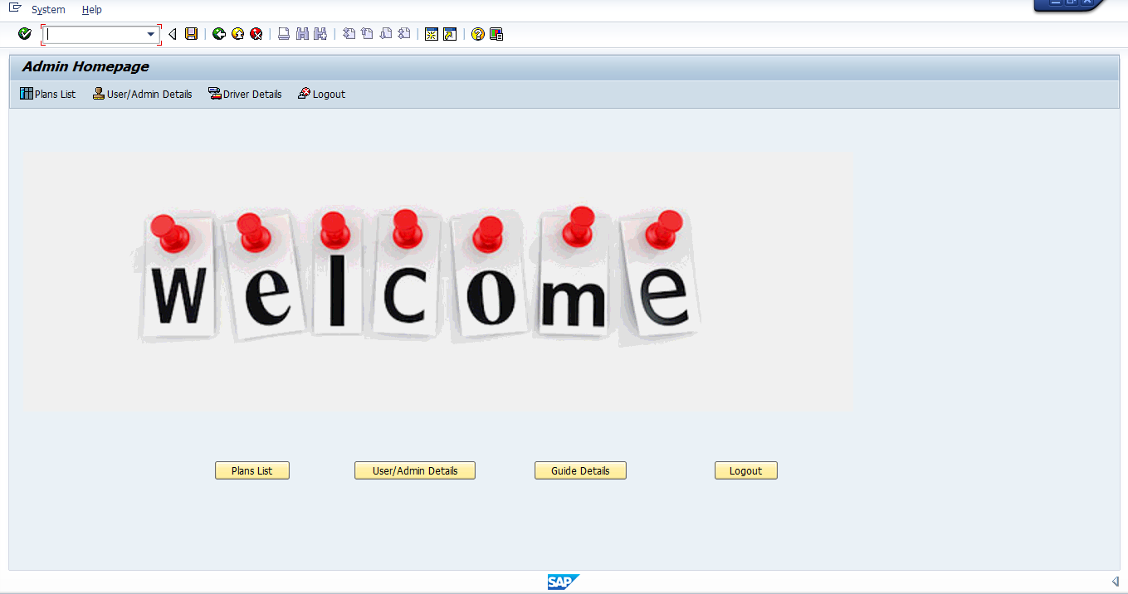

2.) Click on the ‘Guide Details’ button which takes you to the next screen (Guide Navigation Panel) where you have options to view the entire guide details, assign guide to the currently booked tour packages or maintain the guide details.

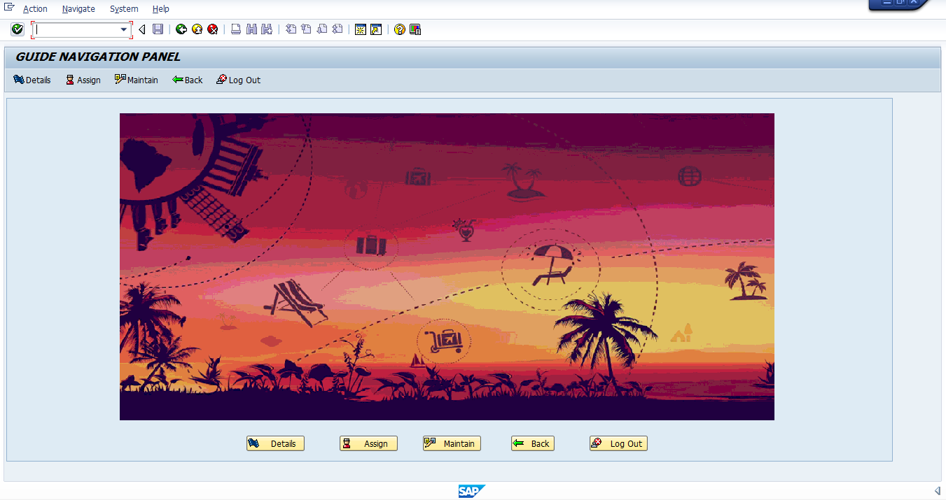

3.) When you click on the ‘Details’ button, a list is generated in the next screen which contains all the details of current guides with their duty status (Y = occupied, N = not occupied).

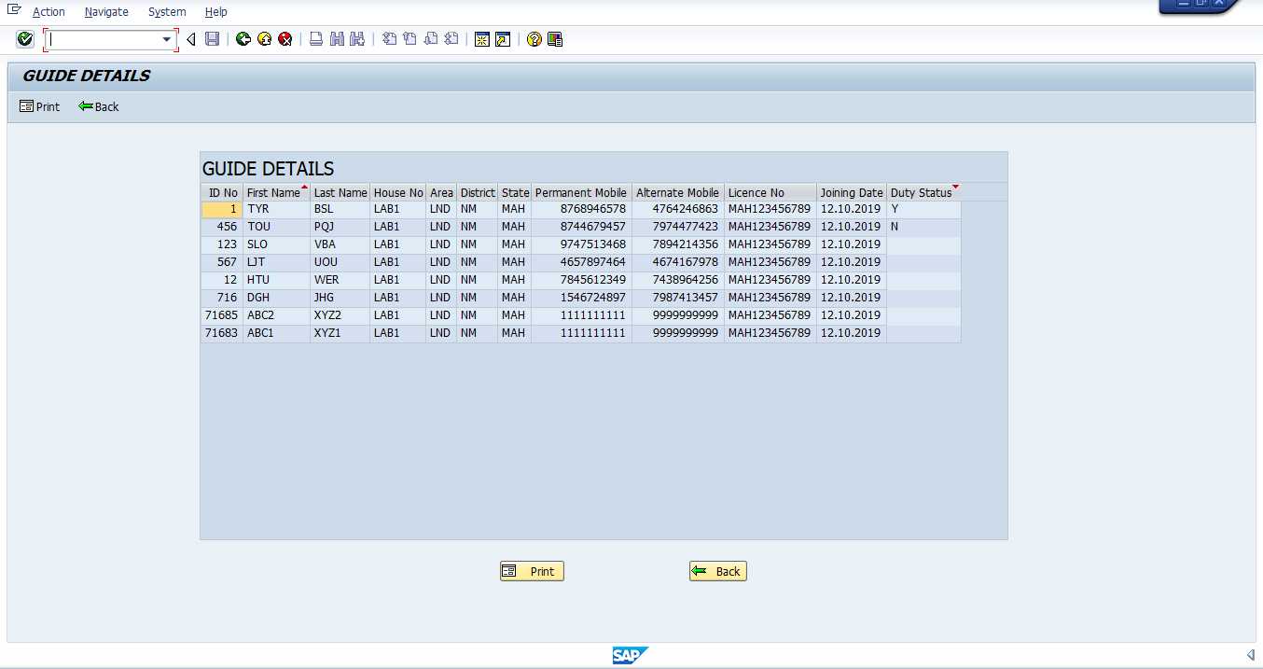

This screen also contains a ‘Print’ button which upon clicking, prints the above details in an adobe form.

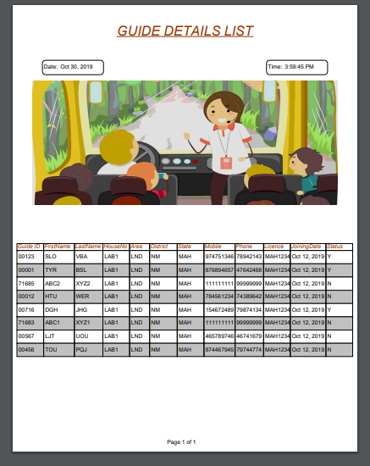

4.) Now press the back button to go to ‘Guide Navigation Panel’. Next, click on ‘Assign’ button which takes you to ‘Tour Package Guide Assignment’ screen. Details of all the currently booked tour packages are displayed on the screen.

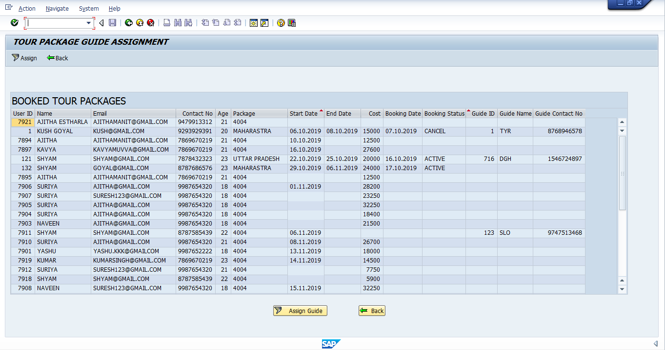

You can either click on ‘Assign Guide’ button or double click on any row to which you want to assign a guide. In the next screen, a search help is provided referring to which you can assign a guide to the selected package.

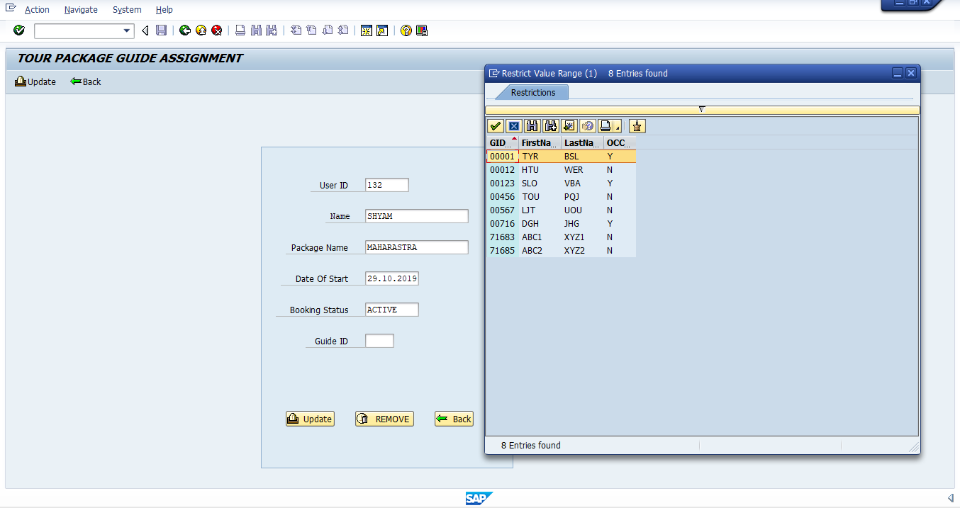

5.) Again go back to the ‘Guide Navigation Panel’ and click on maintain. ‘Maintain Guide Details’ screen is displayed with greyed out fields except guide ID.

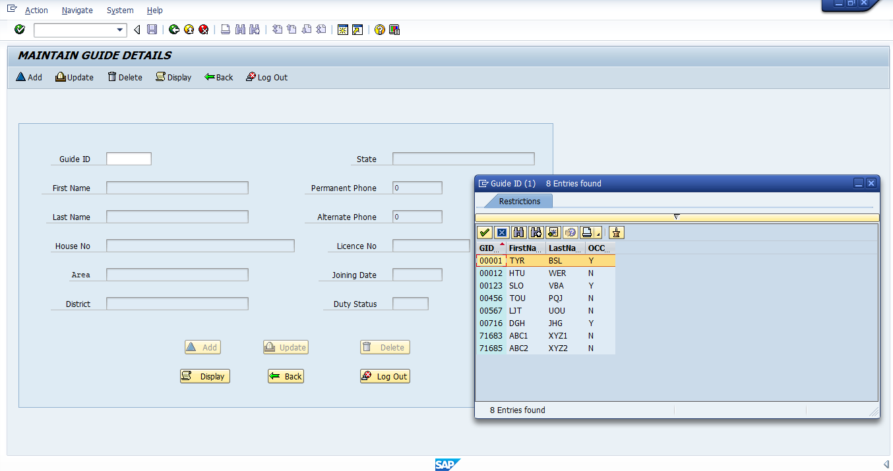

You can either use the search help to enter an existing guide ID and click display or enter a new guide ID and press enter. The greyed out fields now become active and you can fill in relevant details.

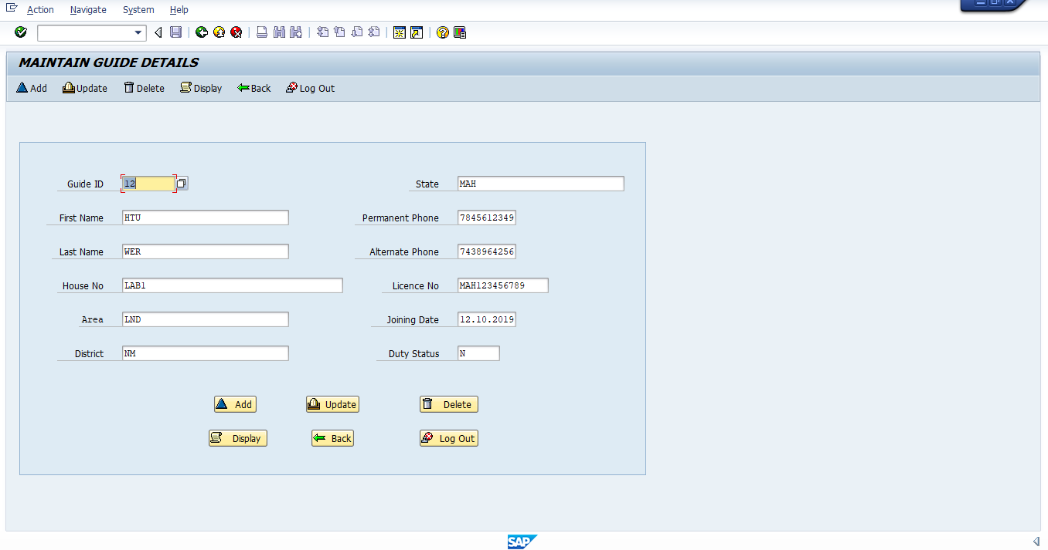

Then, you can perform addition, updation or deletion operation based on you requirement.